**PIZZA SALES SQL QUERIES**

1. KPI’s

Total Revenue

SELECT SUM(total_price) AS Total_Revenue FROM pizza_sales

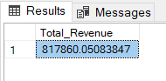

Average order value

SELECT SUM(total_price) / COUNT(DISTINCT order_id) AS average_order_value from pizza_sales

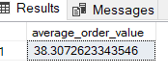

Total Pizzas sold

SELECT SUM(quantity) AS Total_Pizzas_Sold FROM pizza_sales;

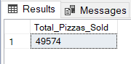

Total Orders Placed

SELECT COUNT(DISTINCT order_id) AS Total_Orders FROM pizza_sales;

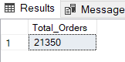

Average pizzas per order

SELECT CAST(CAST(SUM(quantity) AS decimal(10,2)) /

CAST(COUNT(DISTINCT order_id) AS decimal(10,2)) AS decimal(10,2)) AS avg_pizzas_per_order FROM pizza_sales;

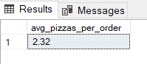

--DAILY TREND

SELECT DATENAME(DW,order_date) as order_day, COUNT(DISTINCT order_id) AS total_orders from pizza_sales

GROUP BY DATENAME(DW, order_date)

--HOURLY TREND

SELECT DATEPART(HOUR, order_time) AS order_hours, COUNT(DISTINCT order_id) AS total_orders from pizza_sales

GROUP BY DATEPART(HOUR, order_time)

ORDER BY DATEPART(HOUR, order_time)

--Percentage of sales across categories

SELECT pizza_category, SUM(total_price)*100/(SELECT SUM(total_price) from pizza_sales WHERE MONTH(order_date) = 1) AS pct_sales

from pizza_sales

WHERE MONTH(order_date) = 1

GROUP BY pizza_category

--Percentage of sales across size

SELECT pizza_size, SUM(total_price) AS total_sales, CAST(SUM(total_price)*100/(SELECT SUM(total_price) from pizza_sales ) AS decimal(10,2)) AS pct_sales

from pizza_sales

GROUP BY pizza_size

ORDER BY pct_sales DESC

--Pizzas sold by category

SELECT pizza_category, SUM(quantity) as total_pizzas_sold

FROM pizza_sales

GROUP BY pizza_category

--top 5 best sellers

SELECT TOP 5 pizza_name, SUM(quantity) as total_pizzas_sold

from pizza_sales

GROUP BY pizza_name

ORDER BY total_pizzas_sold DESC

--bottom 5 best sellers

SELECT TOP 5 pizza_name, SUM(quantity) as total_pizzas_sold

from pizza_sales

GROUP BY pizza_name

ORDER BY total_pizzas_sold